Supplementary Materials

In Section 3.1., we have provided Geweke diagnostics to comment on the convergence of the MCMC algorithm. Additionally, the following trace plots of the simulated parameter values for $β_{0}$, ρ, $α_{1}$, $α_{2}$, $τ^{2}$, and $φ_{11}$ from the MCMC algorithm can be viewed:

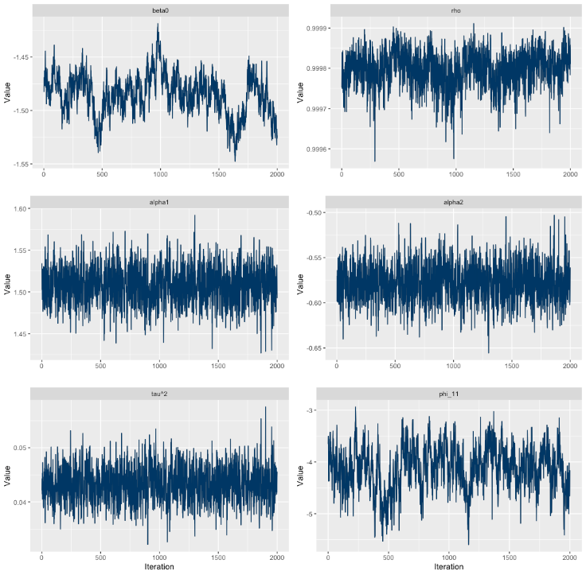

Note that there are 20,904 (312 x 67) random effects, so we only present the trace plot for $φ_{11}$ here.  
The algorithm takes longer to explore the parameter spaces of $β_{0}$ and $φ_{11}$ but none of the six plots shows any pattern that provides strong evidence against convergence.

Section 3.3. looked at regional differences in temporal trends in mortality risks in England. The regions we are referring to are presented on the map below:  
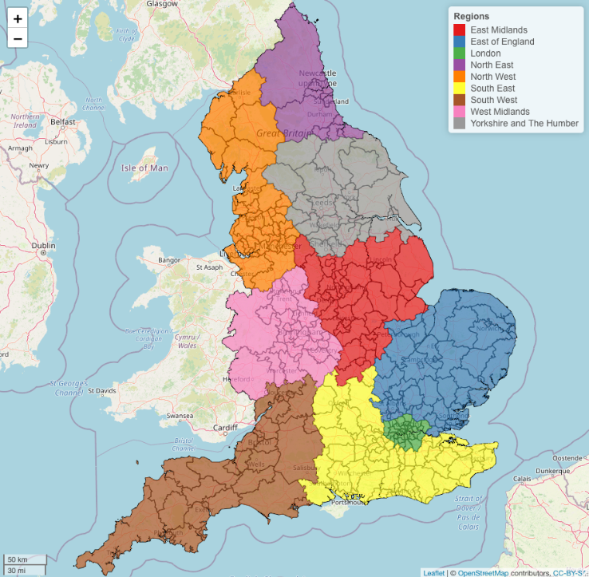

Section 3.4. identified LADs with similar temporal trends in mortality risks using the k-means algorithm. We confirmed that clustering is meaningful for our data by checking the within-cluster sum of squares plots that showed a substantial drop when moving from one cluster to two clusters. We chose the optimal number of clusters by checking the average silhouette plots, which showed that the average silhouette width was the largest for 2 clusters in lockdowns 1 and 3. The plots are provided below:  
